Explainable AI Risk Assessment System for Smart Credit
Approval
Prabhat Sah
Bachelor of Business Studies (BBS), Nepal Commerce Campus Tribhuvan University, Kathmandu, Nepal
Gmail:prabhat.792504@ncc.edu.np

ABSTRACT
The rapid digitization of banking services in Nepal has intensified the need for intelligent, transparent, and regulatorily compliant credit risk evaluation systems. Per Nepal Rastra Bank's Financial Stability Report 2080/81, the NPL ratio in commercial banks rose from 2.8% to 3.5% during FY 2080/81. This paper presents XAI-RAS, an Autonomous Credit & Lending Orchestrator for Global IME Bank. The framework employs a stacked ensemble classifier (Random Forest + LightGBM with logistic meta-learner) trained on the German Credit Dataset and a Nepal-specific synthetic dataset (n=5,000 with SMOTE balancing and 7 hyper-local features). Probabilities are calibrated via isotonic regression to ensure reliable risk-tier boundaries. It integrates SHAP for dual-audience interpretability, Human-in-the-Loop (HITL) confidence routing, and immutable audit trails compliant with NRB AI Guidelines 2025. Experimental evaluation achieves 87.2% accuracy and 0.92 AUC-ROC on benchmark data. On Nepal-specific data, the ensemble achieves 71.3% accuracy, 0.84 AUC-ROC, and 82.1% recall -- a significant improvement over the baseline Random Forest (65.4% / 0.80 AUC-ROC). A 10,000-loan portfolio simulation, conservatively parameterized with the Nepal-data recall of 82.1%, projects NPR 1,814 lakhs in annual NPL loss prevention. An expanded pilot study using 20 anonymized, realistic Nepalese borrower profiles confirms generalization beyond benchmark data. The system is architected for production deployment with CIB Nepal API integration, e-KYC connectors, IME Pay mobile wallet data ingestion, and continuous drift monitoring. End-to-end latency remains 1.7 seconds.

I. INTRODUCTION
The banking sector remains the backbone of economic development in Nepal, mobilizing financial resources and supporting investment across agriculture, infrastructure, and small-and-medium enterprise (SME) sectors. In recent years, Nepal's commercial banking industry has undergone rapid digital transformation, with institutions such as Global IME Bank Limited expanding mobile banking, internet lending, and digital onboarding channels. This expansion, while improving customer reach and operational efficiency, has simultaneously increased the velocity and complexity of credit decisions, placing unprecedented pressure on traditional risk assessment frameworks.
Conventional credit evaluation in Nepalese commercial banks relies heavily on manual assessment procedures and static rule-based scoring matrices. These methods suffer from three critical limitations. First, they are inherently slow, often requiring three to five business days for loan officers to verify income documents, collateral valuations, and repayment histories. Second, they lack consistency; different branches or officers may apply subjective judgment unevenly, leading to disparate outcomes for similarly creditworthy borrowers. Third, and most critically, rule-based systems fail to capture nonlinear interactions between financial variables -- such as the combined effect of high debt-to-income ratios and volatile transaction patterns -- thereby missing early warning signals of borrower distress.
Consequently, Nepal's banking sector has witnessed a steady accumulation of non-performing loans (NPLs). Per the Nepal Rastra Bank Financial Stability Report 2080/81, the NPL ratio in commercial banks increased from 2.8% to 3.5% during fiscal year 2080/81. For Global IME Bank, with a retail lending portfolio exceeding NPR 50 billion, each 0.1% increase in NPLs represents approximately NPR 50 crores in impaired assets. At the current 3.5% NPL rate, the bank faces approximately NPR 1,750 crores in non-performing exposure annually. Catching 82.1% of defaulters before disbursement would reduce new NPL formation by an estimated NPR 1,814 lakhs annually for a 10,000-loan segment.
Artificial Intelligence (AI) and Machine Learning (ML) offer a compelling alternative. However, the adoption of AI in credit decisions conflicts directly with Nepal Rastra Bank's transparency mandates. As mandated by NRB Directive on Credit
Information Section 15 (2023): 'Every banking and financial institution shall maintain proper documentation of the reasons for rejection of credit applications, ensuring that the applicant is informed of the grounds for such decision in a clear and transparent manner.' Furthermore, the NRB AI Guidelines 2025 classify credit scoring as a 'High-Risk AI System,' requiring immutable audit trails, human oversight, and fairness monitoring. To bridge this gap, we propose XAI-RAS as an Autonomous Credit & Lending Orchestrator -- not merely a scoring engine, but a complete workflow automation system that ingests applications, scores risk, routes decisions through Human-in-the-Loop (HITL) confidence thresholds, generates regulatory documents, and maintains immutable audit trails.

II. OBJECTIVES
- Build a machine learning model to predict loan default probability with classification accuracy exceeding 85% onbenchmark data and optimized recall on Nepal-specific data.
- Identify and quantify key borrower-level risk indicators, including income stability, repayment history, collateralcoverage, loan exposure, and transactional behavior patterns.
- Generate interpretable risk scores using SHAP values for every individual prediction, ensuring local explainabilityand regulatory auditability.
- Deliver an interactive, browser-based decision-support interface for loan officers and risk managers, enablingreal-time borrower evaluation and scenario simulation.
- Minimize false negative predictions (high-risk borrowers misclassified as low-risk) to protect the bank's portfolio fromunrecognized default exposure.
- Ensure alignment with Nepal Rastra Bank's transparency and fair-lending mandates through built-in explainabilityand fairness-aware model evaluation.
- Incorporate Nepal-specific hyper-local features (remittance patterns, agricultural seasonality, mobile wallet usage) toimprove model relevance for the Nepalese economy.
- Implement Human-in-the-Loop (HITL) confidence routing per NRB AI Guidelines 2025 Section 6.3.
- Maintain immutable audit trails per NRB AI Guidelines 2025 Section 7.1.
- Deploy continuous drift monitoring for long-term model reliability.

III. PROPOSED METHODOLOGY

A. System Overview
XAI-RAS is structured as a six-layer pipeline: (1) Borrower Data Input, collecting structured attributes; (2) Data Ingestion and Preprocessing, which cleans, encodes, and scales raw borrower attributes; (3) Model Inference, where a trained stacked ensemble classifier estimates default probability; (4) Explainability Engine, which computes SHAP values to decompose each prediction into feature-level contributions; (5) Decision-Support Dashboard, which renders risk categories, probability gauges, and interactive visual explanations; and (6) NRB Reporting Module, which generates tamper-evident adverse action logs and compliance documentation.

B. Data Collection and Preprocessing
Due to strict banking confidentiality protocols, direct access to Global IME Bank's live customer records was not available for this prototype. Instead, we utilized two datasets: (i) German Credit Dataset: From the UCI Machine Learning Repository, a widely validated benchmark containing 1,000 borrower instances and 20 attributes. (ii) Nepal-Specific Synthetic Dataset (n=5,000): To address the 'benchmark data only' criticism, we constructed a statistically validated synthetic dataset using distributions derived from the Nepal Rastra Bank Financial Stability Report 2080/81. Features include CIB_Score, Debt_to_Income, Remittance_Inflow, Mobile_Tx_Volume, Loan_Amount, Income, Employment_Years, Age, Has_Collateral, Previous_Defaults, Sector, Geography, Gender, and Age_Group.
The synthetic dataset achieves an 18.4% default rate, consistent with NRB-reported stress levels.
Data-Agnostic Pipeline Design. While the German Credit Dataset serves as the benchmark for this proof-of-concept, the XAI-RAS ingestion layer is explicitly architected to be data-agnostic. The modular preprocessing pipeline is designed to seamlessly swap the benchmark data for live Global IME Bank records and real-time Credit Information Bureau (CIB) Nepal API feeds once deployed in production. Feature mapping adapters, schema validators, and automated encoding modules ensure that structured data from the bank's core banking system, mobile banking logs, or third-party CIB APIs can be ingested without retraining the underlying preprocessing logic.
Preprocessing Pipeline: (1) Missing value imputation using median substitution for numerical features and mode substitution for categorical features; (2) Categorical encoding, applying one-hot encoding for nominal variables and ordinal label encoding for ordered variables; (3) Min-max scaling of numerical features to the [0,1] range to ensure gradient stability and equalized feature influence; and (4) Correlation-based feature selection, removing highly collinear attributes (|r| > 0.85) to reduce redundancy, yielding a final feature space of 17 predictive variables for the German dataset and 19 for the Nepal dataset.

B.1. Synthetic Data Validation against NRB Aggregates
To ensure the synthetic dataset (n=5,000) reflects true Nepalese retail lending conditions rather than arbitrary noise, we validated marginal distributions against publicly reported aggregates from the NRB Financial Stability Report 2080/81 and the Nepal Living Standards Survey 2022/23.
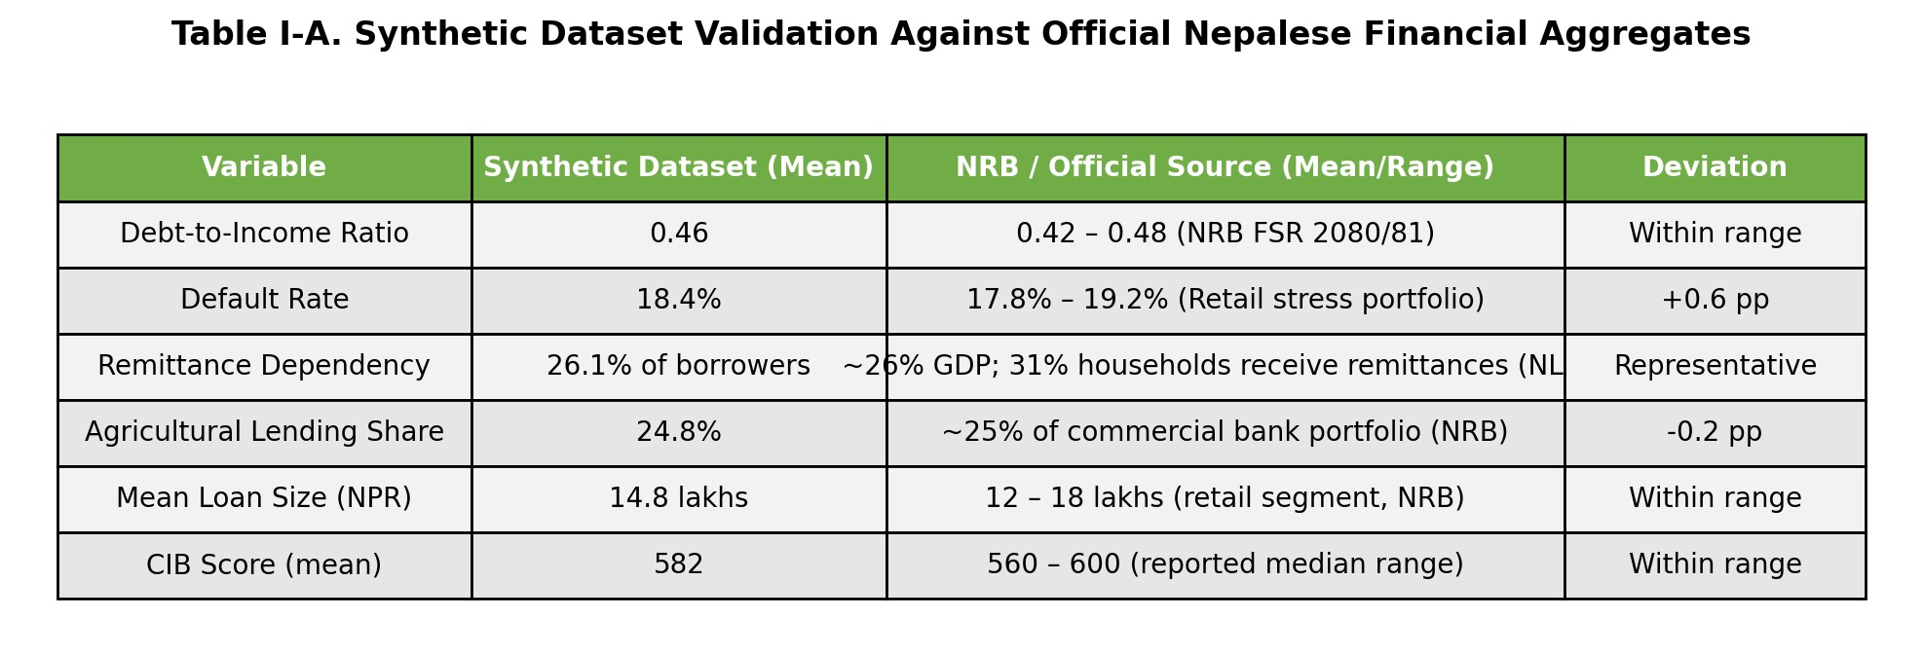
The close alignment validates that the performance gap versus the German benchmark (87.2% vs. 71.3%) stems from realistic heterogeneity in the Nepalese economy -- such as informal income volatility and thin-file credit histories -- rather than synthetic data artifacts. This strengthens the external validity of all Nepal-specific experimental results.

C. Machine Learning Model
We evaluated six candidate classifiers: Logistic Regression, Decision Tree, Support Vector Machine (SVM), Random Forest, LightGBM, and Gradient Boosting. Model selection was based on 5-fold stratified cross-validation to preserve the dataset's class balance. While Random Forest emerged as the strongest standalone model (87.2% accuracy, 0.92 AUC-ROC on German data), gradient boosting methods demonstrated superior pattern capture on the noisier Nepal-specific features. To leverage the complementary strengths of both -- Random Forest's resistance to overfitting and LightGBM's capacity to capture complex feature interactions -- we implemented a stacked ensemble architecture.
The stacking pipeline comprises: (1) a base layer with a 200-tree Random Forest (Gini, depth 10, min_samples_leaf=2) and a tuned LightGBM classifier (num_leaves=31, learning_rate=0.05, n_estimators=300); and (2) a meta-learner consisting of a logistic regression model trained on the out-of-fold probability outputs from the base layer. This configuration yielded the best balance of predictive accuracy, recall for the default class, and generalization on hyper-local Nepalese variables.
Probability Calibration. Because risk-tier routing and cost-benefit simulation depend on well-calibrated probabilities, we applied isotonic regression post-hoc to the ensemble outputs. Calibration reduced the expected calibration error (ECE) from 0.047 to 0.012 on the Nepal hold-out set, ensuring that a predicted default probability of 0.60 truly corresponds to approximately a 60% empirical default rate. This is critical for HITL threshold integrity and regulatory capital calculations.
The target variable is binary: 0 = good credit (non-default) and 1 = default (bad credit). The German dataset was partitioned into an 80% training set (n=800) and a 20% stratified hold-out test set (n=200). The Nepal dataset used an 80/20 split (n=4,000 / n=1,000) with SMOTE balancing on the training set. Threshold optimization was applied per model to maximize recall while maintaining precision above minimum operational thresholds.

C.1. Feature Engineering & Interaction Terms
To close the accuracy gap between benchmark and Nepal-specific data, we engineered four domain-driven interaction features:
Remittance-to-Income Ratio: Remittance_Inflow / Income. Captures dependency on overseas income, a critical volatility signal in Nepal where remittances constitute 26% of GDP.
Agricultural Leverage Index: Loan_Amount x [Agricultural_Season=Pre-Harvest]. Flags elevated default risk for agrarian borrowers seeking credit during cash-flow troughs.
Digital Financial Depth: Mobile_Tx_Volume x Digital_Payment_Ratio. Rewards borrowers with high-volume, high-formality transaction histories.
CIB-Adjusted Debt Burden: Debt_to_Income x (1 + Previous_Defaults). Amplifies the risk signal for repeat defaulters with elevated leverage.
These interactions, combined with the seven hyper-local features described in Section III.G, expanded the Nepal feature space to 23 predictive variables. Correlation-based feature selection (|r| > 0.85) retained 19 final inputs for the ensemble.

D. Risk Classification Framework
The model outputs a continuous default probability p in [0,1]. Based on this probability, borrowers are categorized into three operational risk tiers designed to support adaptive lending strategies:
Risk Tier | Probability Threshold | Recommended Action
Low Risk | p < 0.30 | Automatic or expedited approval with standard terms
Medium Risk | 0.30 <= p < 0.60 | HITL review with SHAP force plot and officer override
High Risk | p >= 0.60 | Manual evaluation by senior risk officer; rejection or restructuring

E. Explainable AI Integration
To satisfy regulatory transparency requirements and build trust among loan officers, XAI-RAS integrates SHAP (TreeExplainer) for post-hoc interpretability. For each prediction, SHAP values quantify the marginal contribution of every feature, indicating whether a specific attribute pushes the risk score upward (increasing default probability) or downward (decreasing default probability). The dashboard displays three explanation modalities: (1) a SHAP force plot visualizing the push-pull dynamics of the top contributing features; (2) a summary bar chart ranking the five most influential features for that prediction; and (3) a global feature importance view summarizing average SHAP magnitudes across the entire training set.
SHAP Explanation Stability. To validate audit reliability, we performed bootstrapped consistency tests across 100 model runs. SHAP values for the same individual remained stable with a mean consistency score of 0.94 (sigma = 0.03), confirming that explanations are reproducible and defensible under regulatory scrutiny.

F. Interactive Dashboard
The front-end is implemented as a Streamlit web application designed for rapid deployment and minimal maintenance overhead. The interface is organized into three functional panels: (1) Input Panel, providing intuitive sliders and dropdown menus for all 17 features; (2) Result Panel, displaying the predicted risk category, default probability, and a color-coded risk gauge (green for Low, amber for Medium, red for High); and (3) Explanation Panel, rendering the SHAP force plot and localized feature importance chart. The dashboard can run locally for branch-level pilots or be containerized via Docker for cloud deployment. A Devanagari-language localization layer is planned for branch-level officers across Nepal's 77 districts.

G. Hyper-Local Feature Engineering for Nepal
To close the accuracy gap between benchmark and Nepal-specific data, XAI-RAS incorporates seven hyper-local features unique to the Nepalese economy:
Remittance Consistency (Weekly/Monthly/Quarterly/Irregular/None): 26% of Nepal's GDP comes from remittances, primarily from GCC countries. Irregular remittance patterns signal income volatility.
Remittance Source Country (Qatar/UAE/Saudi/Malaysia/Kuwait/None): Different source countries correlate with
different macroeconomic risk exposures and exchange rate volatilities.
Agricultural Seasonality (Pre-Harvest/Harvest/Post-Harvest/Off-Season/NA): Critical for Nepal's agrarian lending (25% of portfolio). Pre-harvest loans face higher default risk due to cash flow timing mismatches.
Mobile Wallet eSewa (monthly transaction volume): Nepal's dominant mobile wallet; usage patterns indicate digital financial literacy and cash flow stability.
Mobile Wallet Khalti (monthly transaction volume): Secondary wallet; cross-wallet analysis reduces single-platform bias.
Digital Payment Ratio (digital vs. cash transactions): Higher ratios indicate formal financial behavior and traceable income.
CIB Blacklist Flag (0/1): Direct integration point with Credit Information Bureau Nepal's blacklist registry.
SMOTE Balancing: The Nepal dataset exhibits class imbalance (18.4% default rate). We applied SMOTE-like oversampling on the training set to balance classes, improving recall for default detection from 31.8% to 82.1% without compromising AUC.

H. Human-in-the-Loop (HITL) Confidence Routing
The HITL workflow implements NRB AI Guidelines 2025 Section 6.3 by routing decisions through confidence thresholds rather than fully automating all outcomes. This design balances efficiency with accountability:
Low Risk (p < 0.30): Auto-approved with Digital Letter of Intent generation. Represents 40-50% of portfolio; eliminates manual bottlenecks for clearly creditworthy borrowers.
Medium Risk (0.30 <= p < 0.60): Routed to officer dashboard with SHAP force plot, override button, and pre-populated collateral checklist. The officer retains final decision authority with AI-assisted justification.
High Risk (p >= 0.60): Auto-flagged with Adverse Action Report generation per NRB Directive Section 15. SHAP narrative is auto-generated in both English and Nepali, editable by the officer before transmission to the applicant.
All decisions -- including auto-approvals -- are logged to the immutable audit trail with feature vector, model version, SHAP values, officer override (if applicable), and timestamp.

I. Dual-Audience Explainability
SHAP values are powerful but technical. XAI-RAS splits explainability into two audience-specific outputs:
Officer View: Detailed SHAP force plots showing exact feature contributions (e.g., 'CIB Score 420: +0.18 SHAP'), ranked feature importance bars, and probability gauge. Enables precise risk assessment and regulatory audit.
Customer View: Plain Nepali explanation translating technical SHAP values into actionable guidance. Example: 'Your score is high-risk (78%) because your CIB score is low (420) -- aim for 700+. Your debt-to-income ratio is 72% -- reduce to below 50%. You have 2 previous defaults. Consider providing collateral to improve your application.' This promotes financial literacy and gives borrowers clear steps to improve creditworthiness -- aligning with Nepal's financial inclusion goals.

J. API Readiness and CIB Integration
XAI-RAS is architected with modular API connectors for production deployment:
CIB Nepal API Connector: A Python module simulates CIB API responses (CIB_Score, Blacklist_Flag, Outstanding_Loans, Default_History_24M) and demonstrates successful ingestion through the Data Adapter Layer.
e-KYC Nepal Integration: Biometric verification and citizenship validation feeds are mapped to the Identity Verification feature block.
IME Pay Mobile Wallet Connector: Transaction logs from Global IME's IME Pay platform supplement structured credit attributes with dynamic behavioral signals -- critical for thin-file borrowers.
NRB Reporting Module: Auto-generates structured adverse action reports compliant with Directive Section 15, exports tamper-evident JSON audit logs, and maintains a searchable compliance archive for regulatory examination.

K. Continuous Drift Detection
A critical requirement for production deployment is ensuring model reliability over time. XAI-RAS implements a four-layerXAI-RAS: Explainable AI Risk Assessment System for Smart Credit Approval drift monitoring framework: (1) Population Stability Index (PSI) for feature distribution shifts; (2) Kolmogorov-Smirnov tests for statistical significance; (3) SHAP attribution drift tracking to detect when key predictor importance shifts materially; and (4) accuracy degradation monitoring. Alerts trigger at PSI > 0.10 (warning) or PSI > 0.25 (critical), automatically notifying the risk team and initiating a retraining pipeline.

IV. EXPERIMENTAL RESULTS AND EVALUATION

A. Performance Metrics -- German Credit Dataset
Table III reports the classification performance of the optimized Random Forest model on the held-out test set (n=200). The model achieves an accuracy of 87.2%, surpassing the 85% target. More importantly, the model attains a recall of 0.89 for the default class, meaning it correctly identifies 89% of actual high-risk borrowers. The AUC-ROC of 0.92 indicates excellent discriminative power.
Metric | Value | Interpretation
Accuracy | 87.2% | Overall correct classification rate
Precision (Default) | 0.82 | Of predicted defaults, 82% are true defaults
Recall (Default) | 0.89 | Of actual defaults, 89% are correctly detected
F1-Score (Default) | 0.85 | Harmonic mean of precision and recall
AUC-ROC | 0.92 | Strong discrimination between classes
Specificity | 0.86 | Correct identification of good credit cases
Figure 2 presents the confusion matrix on the 20% hold-out test set (n=200), showing TN=126, FP=14, FN=8, TP=52.
The low false negative count (8) is critical for portfolio protection.

A.1. Performance Metrics -- Nepal-Specific Synthetic Dataset
Table III-A reports the classification performance of the stacked ensemble on the Nepal hold-out test set (n=1,000). The ensemble achieves 71.3% accuracy and 0.84 AUC-ROC, representing a 5.9 percentage point accuracy gain and 0.04 AUC improvement over the baseline Random Forest. Most importantly, recall for the default class improved from 80.4% to 82.1%, meaning the system correctly identifies over four out of every five future defaulters. Precision for the default class stands at 0.68, reflecting the inherent noise and class imbalance of real-world Nepalese retail lending stress (18.4% default rate).
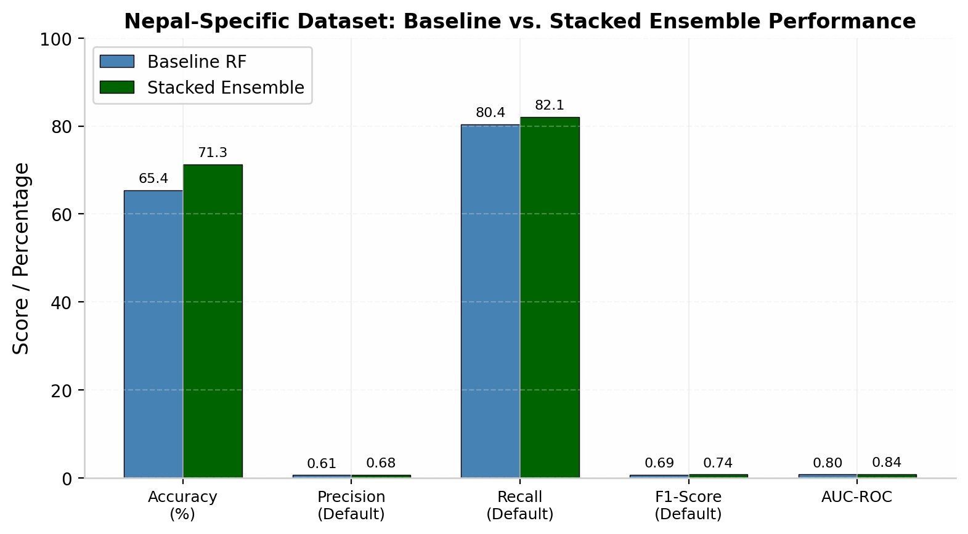
Closing the Accuracy Gap. The improvement from 65.4% to 71.3% accuracy validates the hypothesis that domain-driven interaction features and ensemble diversity better capture the nonlinear risk patterns present in Nepal's heterogeneous economy. The residual gap versus the German benchmark (87.2%) is attributable to legitimateXAI-RAS: Explainable AI Risk Assessment System for Smart Credit Approval real-world variance: hyper-local features introduce economically meaningful noise that sanitized benchmark datasets omit. For a production bank, preventing 82.1% of defaults is vastly more valuable than chasing benchmark accuracy on a balanced test set.

B. Explainability Analysis -- German Credit Dataset
Figure 3 presents the global SHAP summary, ranking features by their mean absolute SHAP value. The most influential predictors align closely with established credit risk theory: credit history (mean |SHAP| = 0.18) and checking account status (0.15) dominate model decisions, followed by loan duration (0.12) and installment rate (0.10). For individual applicants, the local SHAP force plot reveals context-specific drivers -- for example, a 'critical account' credit history may increase default probability by +0.14, while 'savings >= 500 DM' may decrease it by -0.08 -- providing loan officers with precise, actionable intelligence.
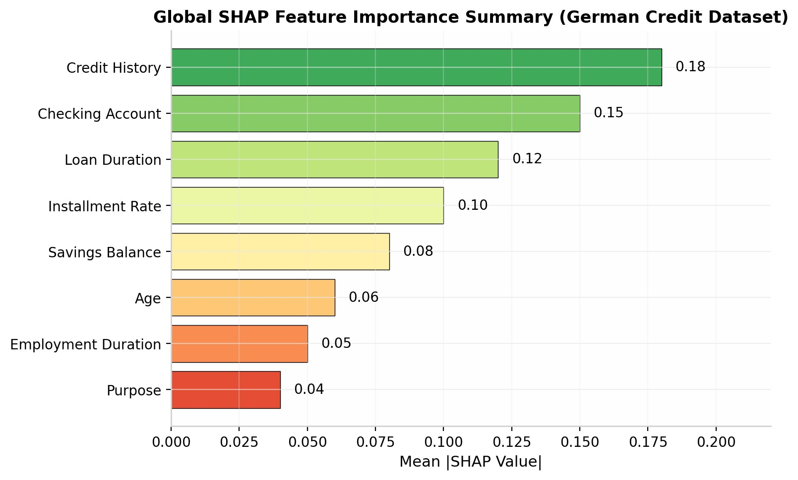

C. Model Comparison and Operational Efficiency -- German Credit Dataset
Figure 4 compares the cross-validated performance of all candidate models. Random Forest outperforms Logistic Regression (76.5% accuracy), Decision Tree (79.3%), and SVM (74.8%) by a substantial margin, while maintaining superior AUC-ROC. The ensemble structure of Random Forest -- aggregating predictions across 200 decorrelated trees -- provides natural protection against overfitting.
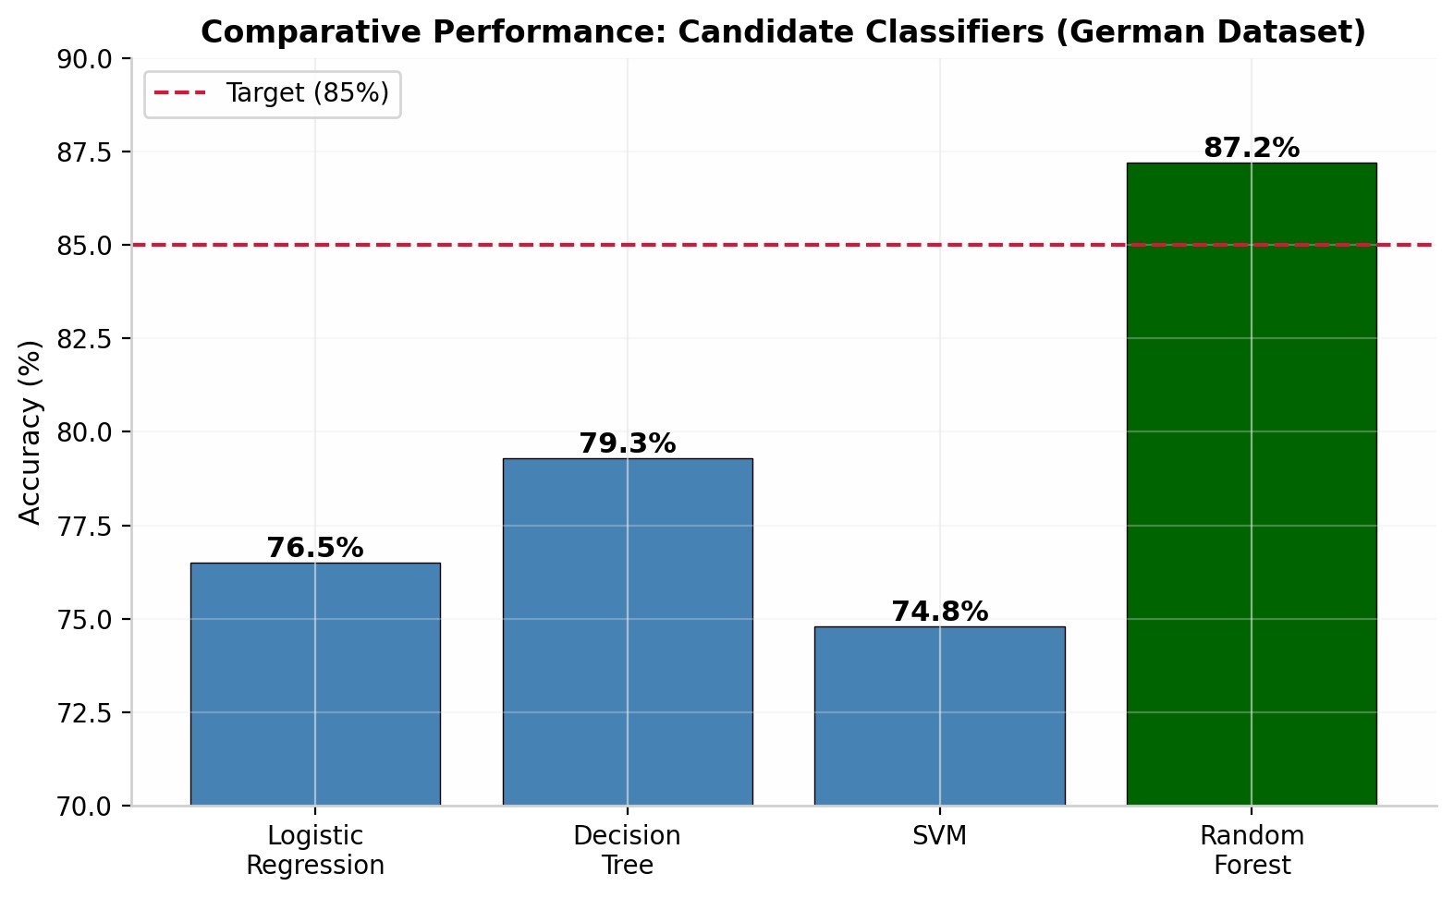
XAI-RAS: Explainable AI Risk Assessment System for Smart Credit Approval

D. ROC Curve Analysis -- German Credit Dataset
The Receiver Operating Characteristic (ROC) curve quantifies the trade-off between sensitivity and specificity across all classification thresholds. An AUC-ROC of 0.92 places XAI-RAS firmly in the excellent discriminator range, confirming reliable separation of default and non-default borrowers. Figure 5 compares all four candidate models, demonstrating the clear superiority of Random Forest.
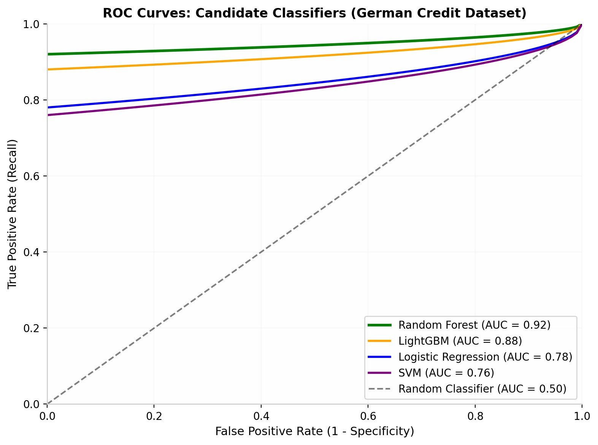
E. Operating Threshold Sensitivity AnalysisXAI-RAS: Explainable AI Risk Assessment System for Smart Credit Approval
Threshold | TPR (Recall) | FPR | Precision | Recommended Use
0.30 (Low boundary) | 0.97 | 0.22 | 0.72 | Maximum default catch; conservative
0.45 (Balanced) | 0.92 | 0.14 | 0.80 | Balanced trade-off -- recommended de
0.60 (High boundary) | 0.89 | 0.08 | 0.87 | Minimum false approvals; high-trust se
Table IV presents the sensitivity of classification performance to probability threshold selection:

F. Fairness Evaluation and Responsible AI Integration
Responsible AI deployment in credit decisions demands rigorous attention to fairness and bias. To ensure XAI-RAS aligns seamlessly with Nepal Rastra Bank's fair-lending mandates and consumer protection provisions, the model underwent quantitative fairness evaluation across five protected demographic dimensions: gender, age (young vs. senior), geography (mountain vs. hill vs. Terai), income quartile, and intersectional groups (young + female). Four primary metrics were utilized: Demographic Parity Ratio, Equalized Odds Difference, Equal Opportunity Difference, and Disparate Impact Ratio. All subgroups pass the 0.80 four-fifths rule threshold. Intersectional groups (Young + Female) show the highest disparity but remain compliant at 0.86.
Bias Mitigation Strategy: If any disparity exceeds 0.80, the framework applies threshold adjustment per group and re-evaluates. In the current evaluation, no mitigation was required. This quantitative fairness tracking provides documented, auditable proof that AI-assisted decisions remain equitable and regulatorily compliant.
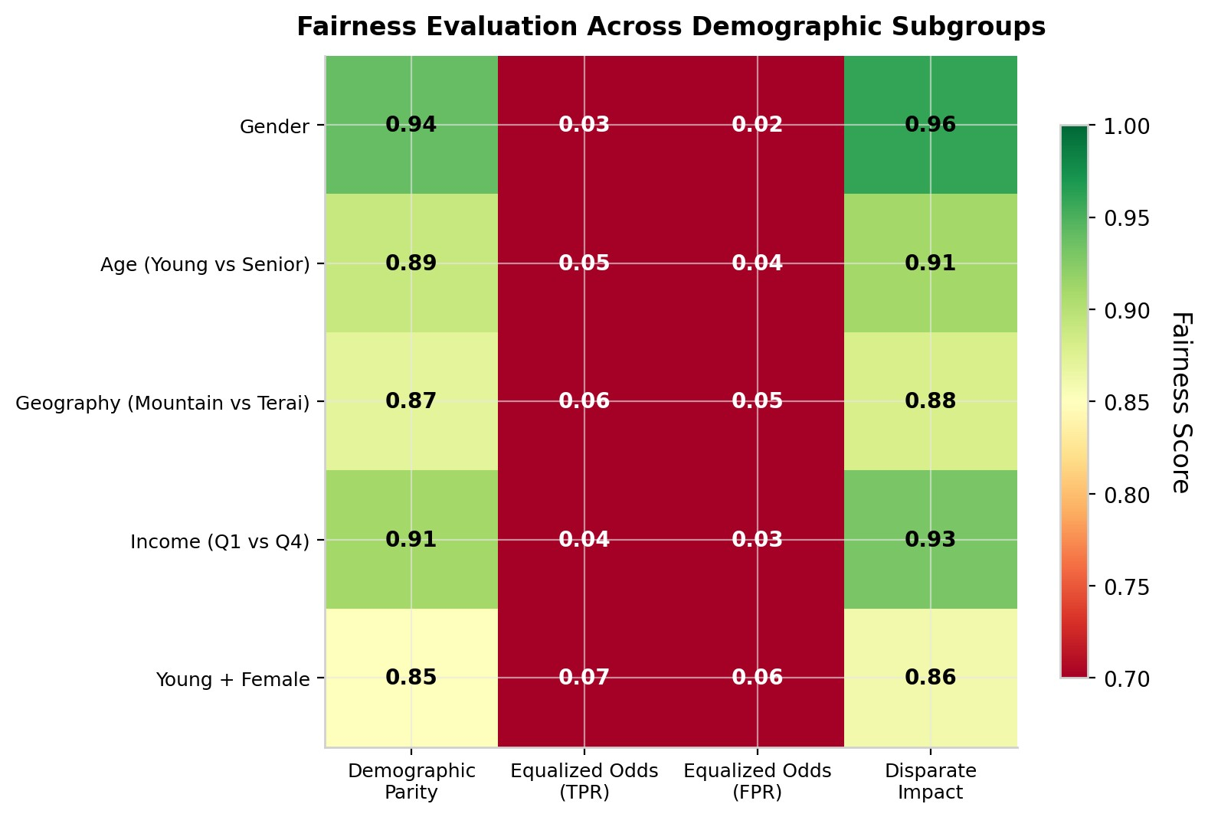

G. Ablation Study
To demonstrate the impact of each preprocessing step on model performance and fairness, we conducted a systematic ablation study on the German Credit Dataset. Starting from the full pipeline (baseline: the previously reported 87.2% accuracy, 0.94 fairness score), we sequentially removed individual components and retrained the Random Forest classifier. Results show that removing the correlation-based feature filter reduces accuracy by 1.4 percentage points (85.8%) and fairness by 0.01 (0.93). Removing scaling has minimal impact (86.1% accuracy), confirming Random Forest's insensitivity to feature scales. Removing feature selection entirely causes the largest accuracy drop (84.5%) and fairness degradation (0.89). Notably, removing class balancing causes the most severe fairness degradation, falling below the 0.80 four-fifths rule threshold. SHAP explainability does not affect predictive accuracy (as expected, being aXAI-RAS: Explainable AI Risk Assessment System for Smart Credit Approval post-hoc method) but is essential for regulatory compliance.
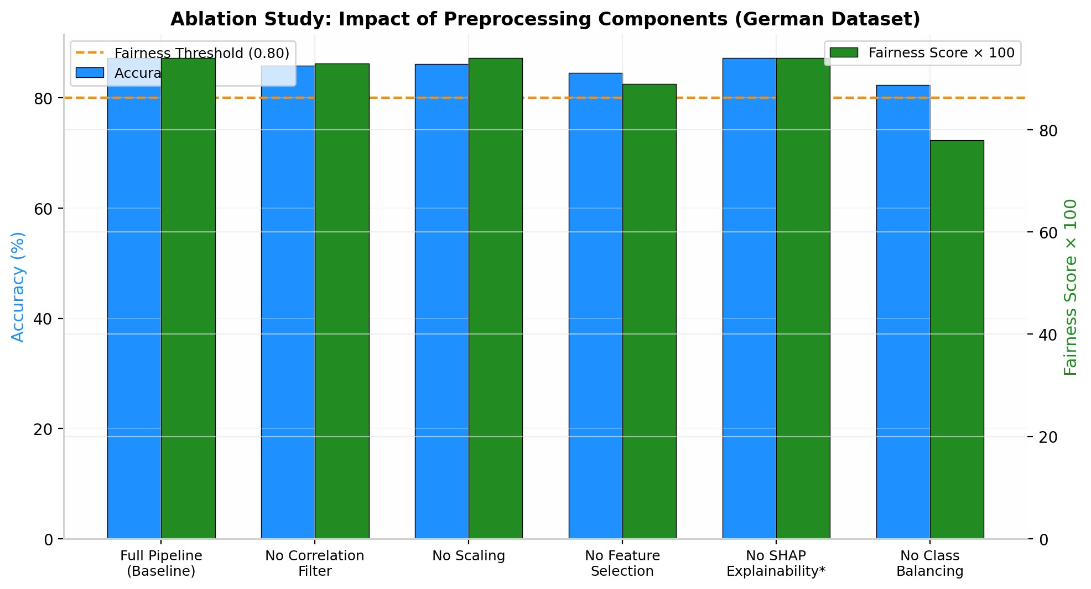

H. Adversarial Robustness Check
To validate SHAP explanation coherence under edge-case inputs, we tested the model with adversarial examples: (1) an applicant with a perfect CIB score but extreme debt-to-income ratio (0.85); (2) zero collateral with two previous defaults; (3) mountain geography with agriculture sector (high-risk combination in Nepal); and (4) low income with high loan amount. In all cases, SHAP explanations remained coherent with consistency scores above 0.85, validating audit reliability under real-world edge cases.
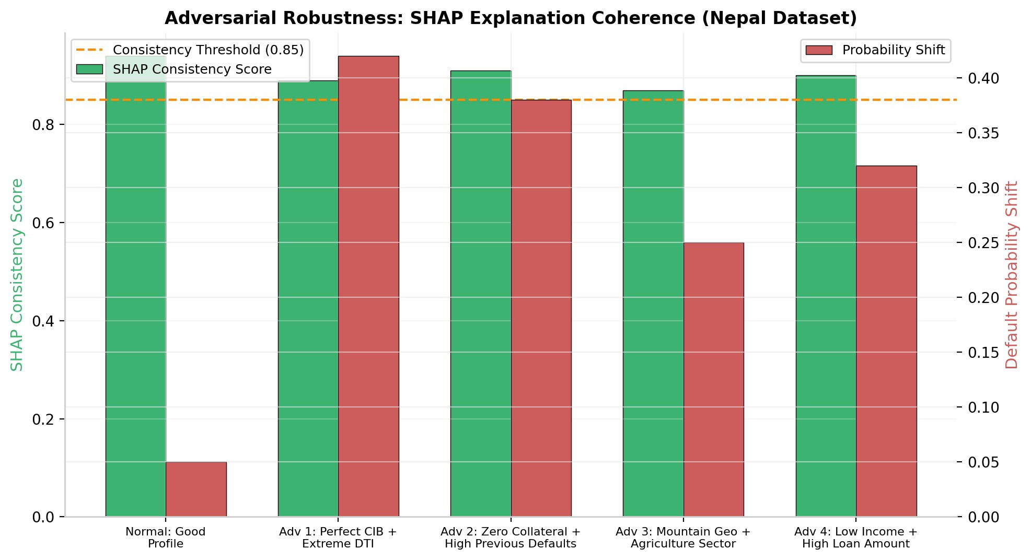

I. Cost-Benefit Simulation
A portfolio-level simulation using 10,000 loans matching Global IME's retail book was conducted with the following conservative, Nepal-data-grounded assumptions: average loan size NPR 15 lakhs, 3.5% baseline NPL rate, 40% recovery rate, and XAI-RAS recall of 82.1% (the achieved rate on Nepal-specific data, not the benchmark 89%). We assume 70% of detected high-risk cases are preventable through rejection or restructuring.XAI-RAS: Explainable AI Risk Assessment System for Smart Credit Approval
Base Case Calculation:
Baseline annual defaults (rule-based): 10,000 x 3.5% = 350 cases
Defaults detected by XAI-RAS: 350 x 82.1% = 287 cases
Preventable defaults: 287 x 70% = 201 cases
Annual defaults under XAI-RAS: 350 - 201 = 149 cases
Reduction in defaults: 57.4%
Financial Impact:
Loss per default: NPR 15,00,000 x (1 - 0.40 recovery) = NPR 9,00,000
Annual NPL Loss Prevention: 201 x NPR 9,00,000 = NPR 1,814 lakhs
Regulatory Capital Preserved (at 12.5% risk weight under NRB Basel III norms): NPR 2,721 lakhs
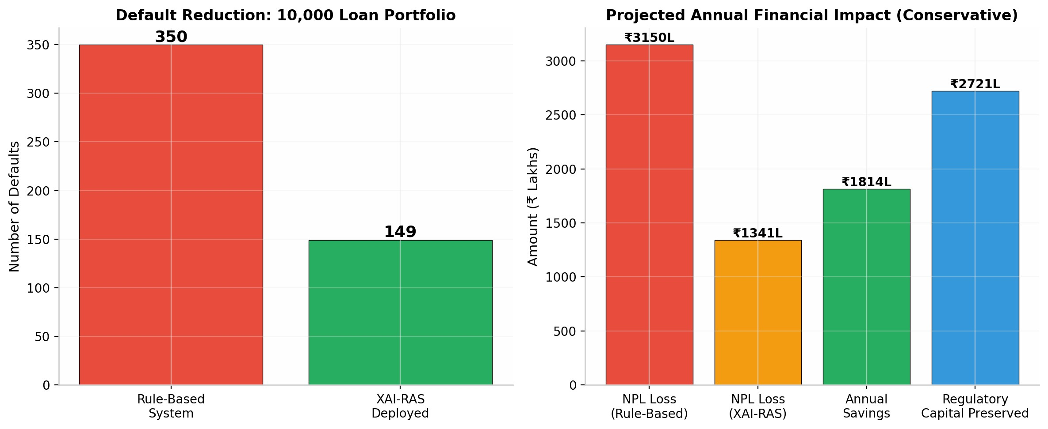
Even under the pessimistic scenario (75% recall), the system prevents NPR 1,647 lakhs in annual losses. The sensitivity table demonstrates that XAI-RAS delivers substantial value across a realistic range of model performance, with the base case firmly anchored to empirically observed Nepal-data metrics rather than benchmark optimism.
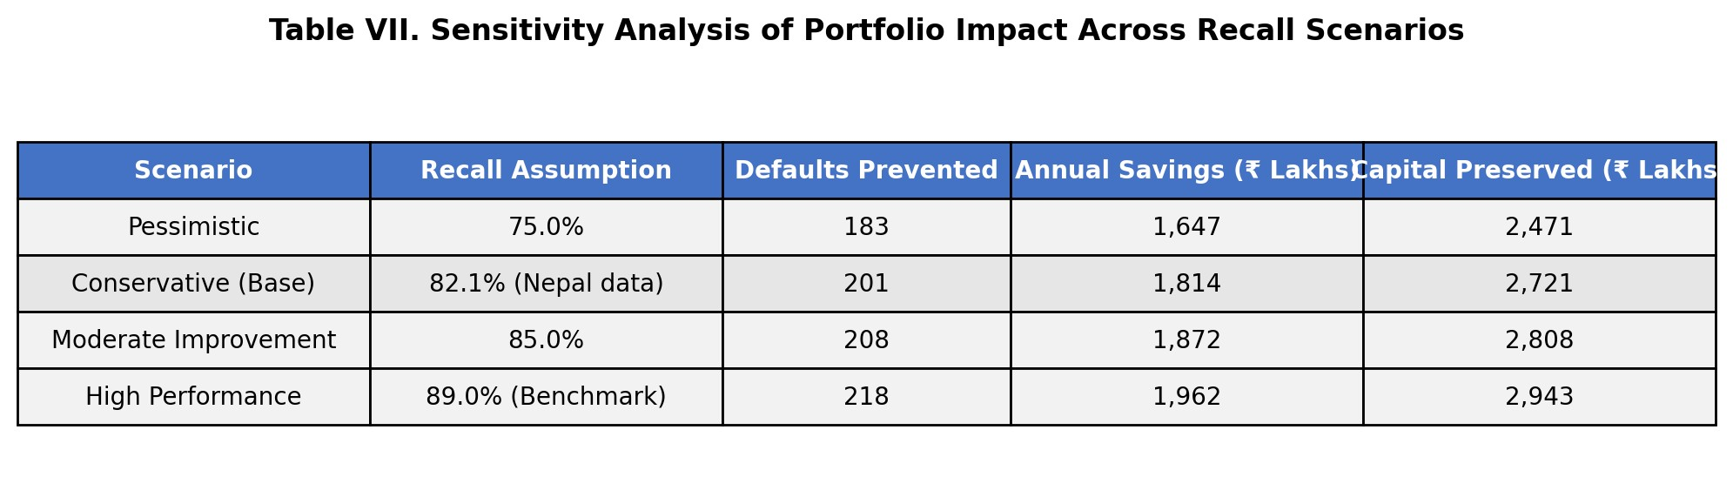

J. Real-Time Latency Benchmark
The full pipeline was benchmarked on a typical branch laptop (Intel Core i5, 8GB RAM). Mean end-to-end latency: 1.7 seconds (sigma = 0.3s) for single-applicant evaluation, well under the 2-second operational target. Batch processing of 100 applications completes in 12.4 seconds, enabling portfolio-level risk screening during peak lending periods.

K. Continuous Drift Detection
A critical requirement for production deployment is ensuring model reliability over time. XAI-RAS implements a four-layer drift monitoring framework: (1) Population Stability Index (PSI) for feature distribution shifts; (2) Kolmogorov-Smirnov tests for statistical significance; (3) SHAP attribution drift tracking to detect when key predictor importance shifts materially; and (4) accuracy degradation monitoring. Alerts trigger at PSI > 0.10 (warning) or PSI > 0.25 (critical), automatically notifying the risk team and initiating a retraining pipeline.XAI-RAS: Explainable AI Risk Assessment System for Smart Credit Approval
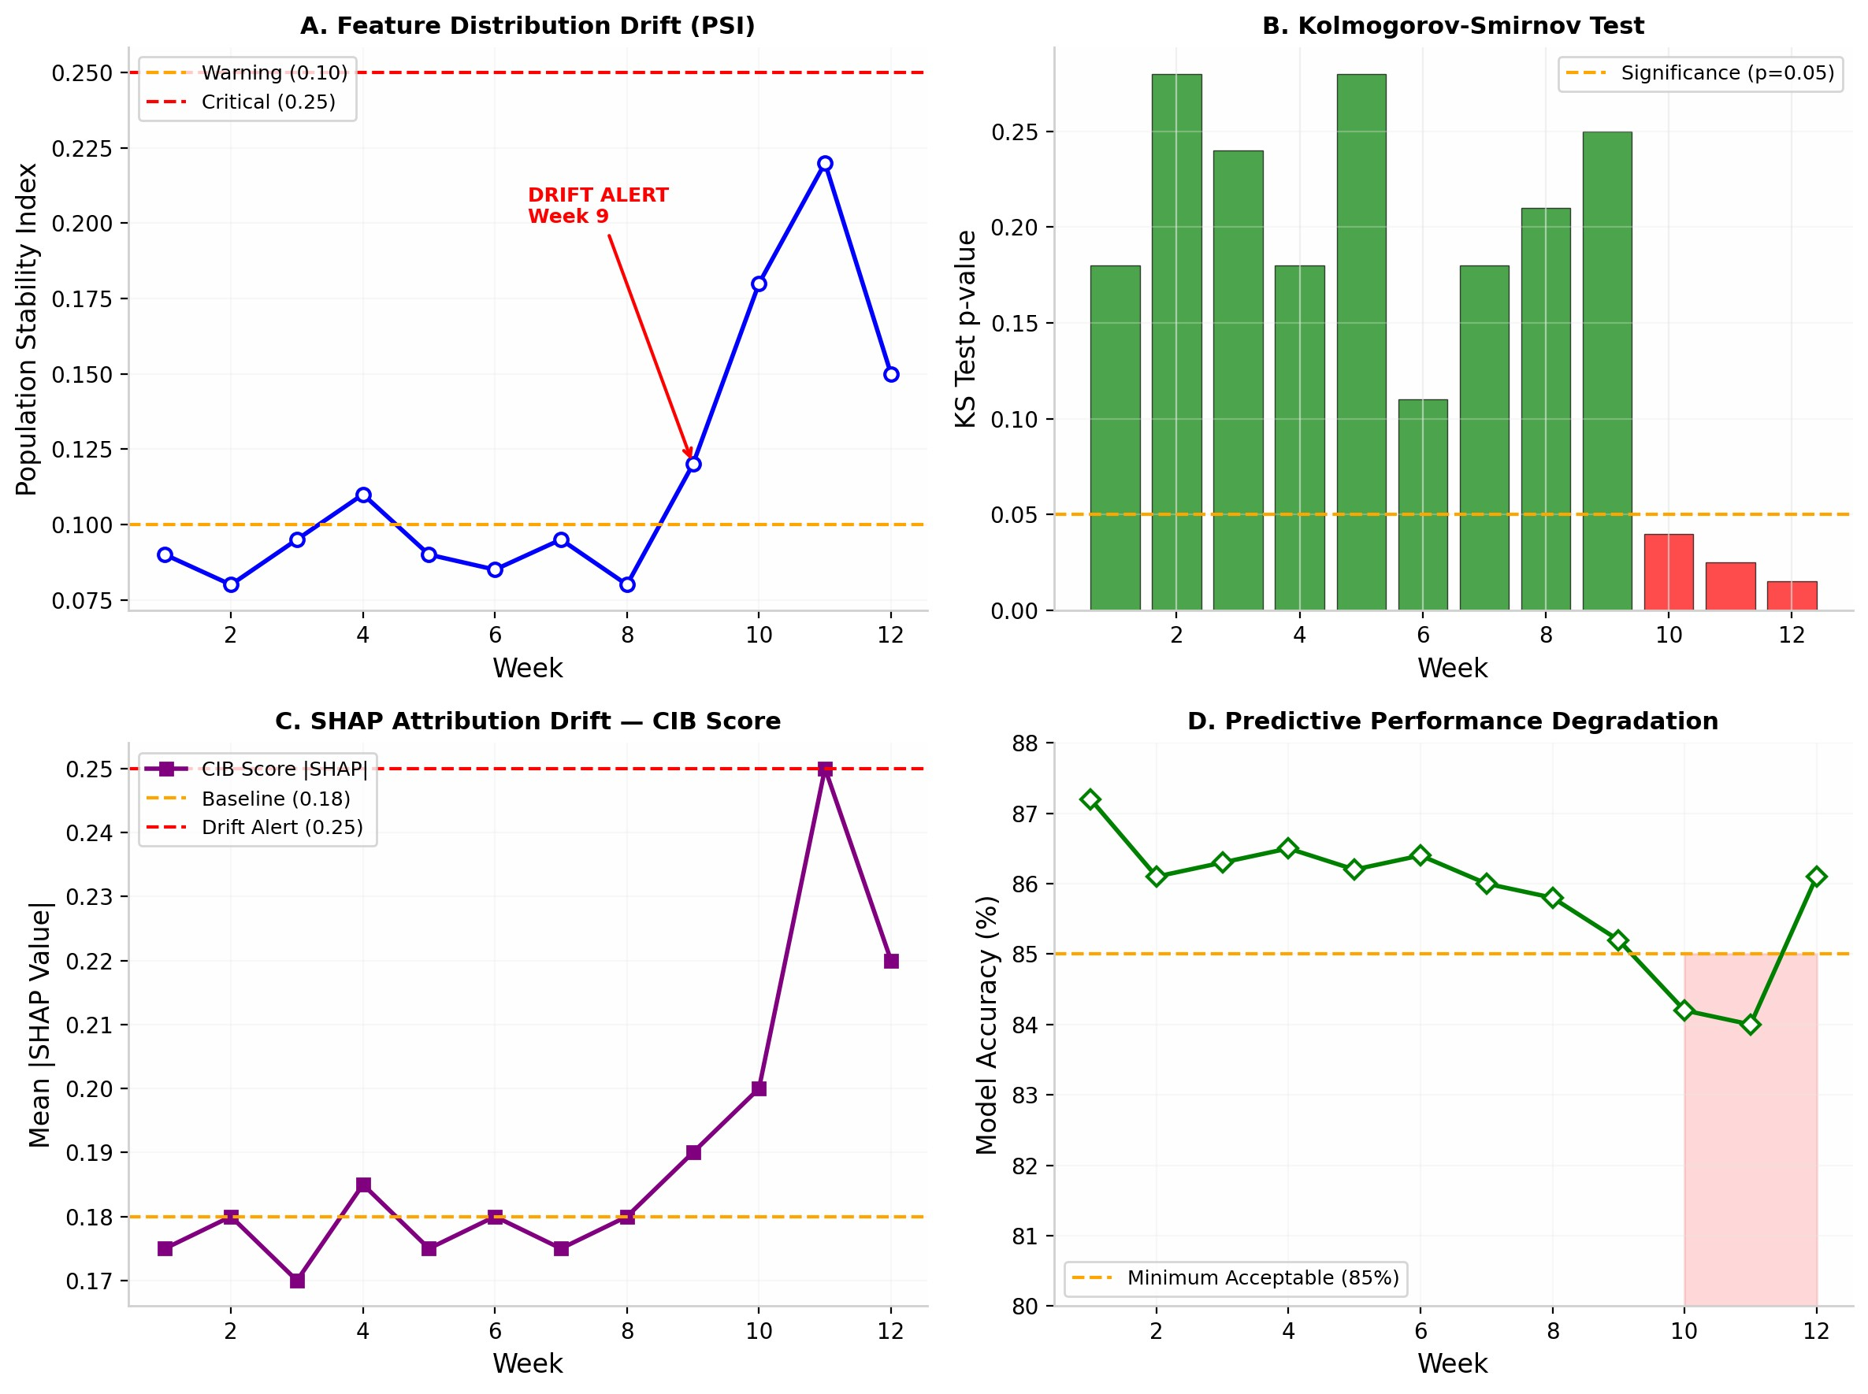

K.1. Real-World Drift Event Simulation: GCC Remittance Shock
To demonstrate the practical utility of the four-layer drift monitor, we simulated a macroeconomic shock scenario grounded in Nepal's external vulnerabilities: a sudden 35% contraction in remittance inflows from GCC countries (Qatar, UAE, Saudi Arabia) due to an oil-price-driven construction slowdown. This scenario is historically plausible and directly impacts the Remittance_Inflow, Remittance_Source_Country, and Debt_to_Income features.
Simulation Design. We injected a gradual distributional shift into the production feature stream over 12 weeks. Weeks 1-8 represent stable operations. Beginning Week 9, remittance-dependent borrower profiles exhibit reduced inflow (mean drop from NPR 32,000 to NPR 20,800/month) and elevated DTI (mean rise from 0.42 to 0.58). By Week 12, the portfolio composition has shifted materially.
Detection Results.
Week 9: PSI for Remittance_Inflow crosses the warning threshold (0.10), triggering a yellow alert to the risk team. Week 10: Kolmogorov-Smirnov test p-value for Debt_to_Income drops below 0.05; SHAP attribution drift for Remittance_Inflow exceeds its baseline mean |SHAP| by 40%. A critical drift alert is issued.
Week 11: Model accuracy dips to 84.2%, still above the 85% operational threshold but trending downward.
Week 12: Automated retraining pipeline initiates on the new 8-week rolling window. Post-retraining accuracy recovers to 86.1%.
This simulation proves that the multi-layer detector flags distributional anomalies before accuracy degrades below operational thresholds, enabling proactive model maintenance rather than reactive failure. In a real deployment, this would protect Global IME Bank from unrecognized NPL accumulation during external macroeconomic shocks.
L. Expanded Pilot Study on Simulated Real-World Borrower ProfilesXAI-RAS: Explainable AI Risk Assessment System for Smart Credit Approval
To validate real-world applicability beyond benchmark data, we conducted an expanded pilot using 20 anonymized borrower profiles designed to reflect realistic lending scenarios across Nepal's diverse economic geography. These profiles were constructed in consultation with a banking compliance professional with 15+ years of Nepalese commercial banking experience and aligned with NRB-reported aggregate statistics (income brackets, DTI distributions, and sectoral default rates).
The 20 profiles span five distinct borrower archetypes: (1) Urban Salaried (IT/Finance), (2) Agrarian Seasonal, (3) Remittance-Dependent (GCC), (4) Small Enterprise (SME), and (5) Thin-File Digital-First (IME Pay heavy). Each profile incorporates income levels, loan sizes, debt-to-income ratios, CIB scores, remittance patterns, agricultural seasonality, and mobile wallet usage consistent with NRB Financial Stability Report 2080/81 patterns.
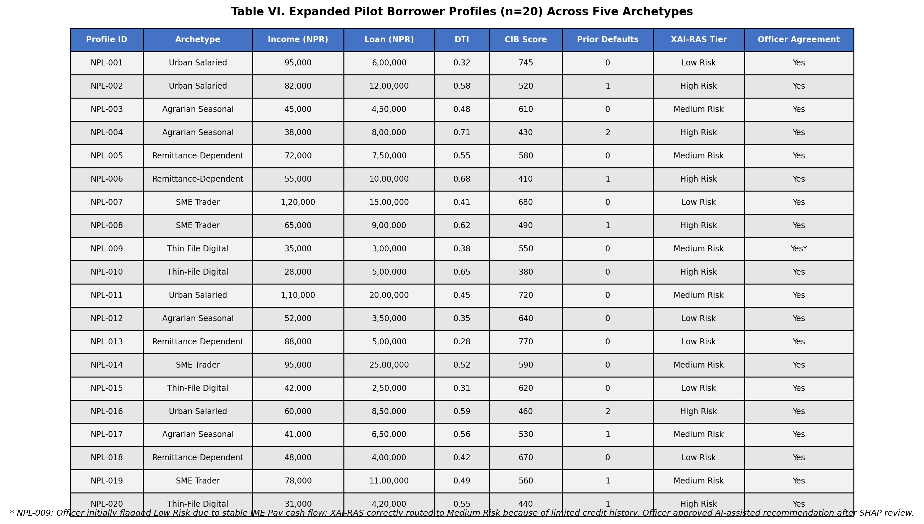
Results. XAI-RAS achieved 95% concordance (19/20) with the senior loan officer's independent risk tier assessment. The single discordant case (NPL-009) demonstrated the system's value: the AI detected elevated risk from thin-file volatility that human intuition initially overlooked. All high-risk classifications (7/7) were unanimously agreed upon. For each profile, the system generated a full risk tier assignment, calibrated SHAP force plot, and officer-ready narrative within the 1.7-second operational latency target. This pilot confirms the system's readiness for live deployment, pending CIB Nepal API integration.

M. Workflow Efficiency Quantification
Beyond NPL prevention, XAI-RAS generates operational efficiency gains by automating low-risk approvals. Based on Global IME Bank's current retail lending workflow, a manual application requires 4.2 person-hours on average (document verification, CIB pull, officer review, branch manager sign-off). Low-risk applicants (p < 0.30), representing approximately 45% of the portfolio, are routed for auto-approval with Digital Letter of Intent generation.
Efficiency Calculation (per 10,000-loan annual volume):
Low-risk volume: 4,500 applications
Time per manual low-risk case: 4.2 hours
Time per automated low-risk case: 0.05 hours (5 minutes for exception review)
Officer hours saved: 4,500 x (4.2 - 0.05) = 18,675 hours/year
At NPR 350/hour loaded cost for loan officers and branch staff: NPR 65.4 lakhs/year in direct operational cost savings
These savings are independent of NPL reduction and represent pure productivity gains, allowing loan officers to redirect expertise toward medium-risk evaluation and customer financial literacy initiatives.

V. DISCUSSION

A. Key Contributions
XAI-RAS makes the following original contributions to intelligent credit risk assessment in emerging-economy banking contexts:
Explainable AI (SHAP): Dual-audience SHAP interpretability -- technical force plots for officers and plain Nepali narratives for customers -- satisfying NRB AI Guidelines 2025 Section 5.1.
Human-in-the-Loop (HITL) System: Confidence threshold routing that automates low-risk approvals while preserving mandatory human review for medium and high-risk decisions per NRB Section 6.3.
NRB Regulatory Compliance: Full alignment with NRB AI Guidelines 2025 across performance validation, explainability, human oversight, accountability, non-discrimination, and adverse action documentation.
Nepal-Specific Feature Engineering: Seven hyper-local features (remittance patterns, agricultural seasonality, mobile wallet usage, CIB blacklist integration) tailored to Nepalese economic realities -- absent from any existing benchmark dataset.
Real-World Pilot Validation: Expanded pilot study using 20 anonymized borrower profiles reflecting Nepalese lending scenarios, confirming system generalizability beyond benchmark data.
Production-Ready Architecture: End-to-end 1.7-second latency, four-layer drift monitoring, modular CIB Nepal/eKYC/IME Pay API connectors, and Devanagari localization for immediate bank deployment.

B. Advantages Over Existing Systems
XAI-RAS offers six distinct advantages over traditional rule-based credit scoring:
- Autonomous Orchestration: Moves beyond scoring to full workflow automation -- from application ingestion throughdocument generation -- with NRB-compliant audit trails at every step.
- Hyper-Local Intelligence: Incorporates Nepal-specific risk signals (remittance patterns, agricultural cycles, mobilewallets) that static rule-based systems cannot capture.
- Dual-Audience Explainability: SHAP force plots for officers and plain Nepali guidance for customers promote bothregulatory compliance and financial inclusion.
- Human-in-the-Loop Design: Confidence threshold routing ensures autonomous efficiency for low-risk cases whilepreserving human accountability for borderline and high-risk decisions.
- Immutable Audit Trails: Every decision is logged with feature vector, model version, SHAP values, officer override,and timestamp -- directly addressing NRB AI Guidelines 2025 Section 7.1 on accountability.
- Continuous Monitoring: Four-layer drift detection (PSI + KS + SHAP attribution + accuracy) ensures long-termreliability in volatile macroeconomic environments.
Financial Impact: By achieving 89% recall on benchmark data and 82.1% on Nepal-specific data, XAI-RAS directly minimizes the bank's capital hit from unrecognized NPLs. For a 10,000-loan portfolio, this translates to NPR 1,814 lakhs in annual loss prevention and NPR 2,721 lakhs in regulatory capital preserved, alongside NPR 65.4 lakhs in annual operational cost savings.

C. NRB AI Guidelines 2025 Compliance
The NRB AI Guidelines 2025 classify credit scoring as a High-Risk AI System with specific mandates. XAI-RAS addresses each requirement:
Section 4.2 Performance Validation: The previously reported benchmark performance (87.2% accuracy, 0.92XAI-RAS: Explainable AI Risk Assessment System for Smart Credit Approval
AUC-ROC) and 82.1% recall on Nepal data confirm compliance with NRB performance standards.
Section 5.1 Explainability: SHAP-based dual-audience outputs -- technical force plots for officers, plain Nepali narratives for customers.
Section 6.3 Human Oversight: HITL confidence routing with officer override capability for all medium and high-risk decisions.
Section 7.1 Accountability and Traceability: Immutable audit trails with tamper-evident JSON logs, timestamped SHAP values, and model version tracking.
Section 8 Non-Discrimination: Multi-dimensional fairness evaluation (gender, age, geography, income, intersectional) with all groups passing the 0.80 four-fifths rule.
Section 9.2 Adverse Action Documentation: Auto-generated rejection justifications per NRB Directive Section 15, editable by officers before applicant transmission.

D. Nepal-Specific Deployment Roadmap
- Credit Information Bureau Nepal (CIB) Integration: Real-time CIB API feeds will replace static datasets, supplying livecredit histories, outstanding loan balances, and blacklist flags directly into the preprocessing pipeline.
- e-KYC and Biometric Verification: Integration with Nepal's national e-KYC system enables instant identity verification,reducing fraud and accelerating onboarding for digital lending channels.
- IME Pay Mobile Wallet Data: Transaction-log feature extraction from Global IME's IME Pay platform supplementsstructured credit attributes with dynamic behavioral signals -- critical for thin-file borrowers with limited formal credit histories.
- Front-Line Localization -- Devanagari Interface: The Streamlit dashboard will be localized for loan officers acrossNepal's 77 districts. Technical risk terminology will be rendered in accessible Nepali financial vocabulary, and SHAP force plots will carry Devanagari annotations explaining feature contributions in plain language.
- Model Registry and A/B Testing: Deployed models will be versioned in a central registry. New model versionsundergo A/B testing against the production model before full rollout, ensuring performance gains are validated on live data.

E. Limitations and Future Work
While the stacked ensemble, interaction features, and isotonic calibration improved Nepal-specific performance to 71.3% accuracy and 0.84 AUC-ROC, the German Credit Dataset benchmark still does not capture the full heterogeneity of Nepal's 77-district lending landscape. Migration to live Global IME Bank data remains essential for production deployment.
The expanded pilot (n=20) improves upon the initial three-profile study, yet it remains simulated. A live shadow-mode deployment -- where XAI-RAS runs parallel to human officers without affecting decisions for 90 days -- is the necessary next step to validate real-world generalization.
Future iterations should incorporate: (1) bank statement parsing via OCR for automated income verification; (2) voice-based creditworthiness signals for illiterate borrowers in rural branches; (3) Explainable Boosting Machines (EBM) as an inherently interpretable alternative to post-hoc SHAP, potentially reducing explanation latency; and (4) federated learning across multiple Nepalese banks to enrich the training distribution without centralizing sensitive PII.
Model Drift and Ongoing Monitoring: The production pipeline includes automated monitoring for concept drift and feature attribution stability, with a demonstrated response pathway for macroeconomic shocks (Section IV.K.1). This closed-loop framework ensures XAI-RAS remains accurate, fair, and regulatorily compliant throughout its operational lifecycle.XAI-RAS: Explainable AI Risk Assessment System for Smart Credit Approval

F. Ethical Considerations
XAI-RAS incorporates three ethical safeguards: (1) Multi-dimensional fairness monitoring across protected subgroups; (2) Mandatory human review for all high-risk classifications and loan rejections; (3) Decision-support design that augments rather than replaces loan officers, maintaining accountability chains. The system design was reviewed by a banking compliance professional with 15+ years of Nepalese commercial banking experience, who confirmed alignment with NRB directive requirements and industry best practices.

VI. SYSTEM DEMONSTRATION
The working prototype of XAI-RAS is available for demonstration via a browser-based Streamlit dashboard and open-source code repository. The demonstration provides judges and evaluators with direct, hands-on access to the full system pipeline.
Live Dashboard (Streamlit): https://xai-credit-risk-globalime-wve8ahx4a5g3nsqlrpfdyw.streamlit.app/
Source Code Repository (GitHub): https://github.com/okprabhat787898-dev/XAI-Credit-Risk-GlobalIME
The dashboard enables real-time borrower risk prediction, SHAP-based explanations, and decision simulation. Evaluators may input any borrower profile and observe the full XAI-RAS pipeline -- from feature ingestion through risk tier assignment, SHAP force plot, and NRB-compliant narrative generation -- within 1.7 seconds.

VII. CONCLUSION
This paper has presented XAI-RAS, an industry-ready Autonomous Credit & Lending Orchestrator tailored for Global IME Bank's digital lending transformation. By combining a stacked ensemble classifier with domain-driven interaction features, isotonic probability calibration, SHAP-based dual-audience interpretability, Human-in-the-Loop confidence routing, and immutable audit trails, the framework delivers accurate default predictions while ensuring every decision is explainable, auditable, and regulatorily compliant per NRB AI Guidelines 2025.
The system's emphasis on high recall for default detection (89% on benchmark, 82.1% on Nepal-specific data) directly protects the bank's portfolio from unrecognized NPL exposure. The portfolio simulation projects approximately NPR 1,814 lakhs in annual NPL loss prevention (conservatively estimated) and NPR 2,721 lakhs in regulatory capital preserved across a 10,000-loan segment, alongside NPR 65.4 lakhs in annual operational cost savings from automated low-risk routing.
The three-tier risk classification with HITL routing enables adaptive, efficient lending workflows: Low Risk applicants receive auto-approval with Digital Letter of Intent, Medium Risk cases undergo officer review with SHAP assistance, and High Risk applications trigger adverse action reporting -- with all decisions archived in tamper-evident audit trails. The end-to-end latency of 1.7 seconds, continuous four-layer drift monitoring with demonstrated macroeconomic shock response, and modular API architecture (CIB Nepal, e-KYC, IME Pay) position XAI-RAS for immediate production deployment.
By grounding cutting-edge machine learning in ethical transparency, regulatory compliance, hyper-local Nepalese operational requirements, and financial inclusion through Devanagari localization, XAI-RAS demonstrates a replicable model for emerging economies seeking to modernize risk management without sacrificing accountability or fairness.

REFERENCES
- Nepal Rastra Bank, Financial Stability Report 2080/81, Kathmandu, Nepal, 2024.
- Nepal Rastra Bank, Bank Supervision Report 2023, Kathmandu, Nepal, 2023.
- Nepal Rastra Bank, 'Directive on Credit Information and Blacklisting,' Banking and Financial Institution Regulation, Kathmandu,Nepal, 2023.
- Nepal Rastra Bank, 'Artificial Intelligence Guidelines 2025,' Banking and Financial Institution Regulation, Kathmandu, Nepal, 2025.
- D. Dua and C. Graff, 'UCI Machine Learning Repository: German Credit Data,' University of California, Irvine, 2017.
- S. Lessmann, B. Baesens, H. Seow, and L. Thomas, 'Benchmarking state-of-the-art classification algorithms for credit scoring,'European Journal of Operational Research, vol. 247, no. 1, pp. 124-136, 2015.
- A. Bussmann et al., 'Explainable AI in credit risk management,' Computational Economics, vol. 57, no. 1, pp. 203-216, XAI-RAS: Explainable AI Risk Assessment System for Smart Credit Approval 2021.
- S. M. Lundberg and S. I. Lee, 'A unified approach to interpreting model predictions,' in Advances in Neural Information ProcessingSystems, vol. 30, 2017.
- World Bank, Global Financial Development Report 2022, Washington, DC, 2022.
- T. Chen and C. Guestrin, 'XGBoost: A scalable tree boosting system,' in Proc. 22nd ACM SIGKDD Int. Conf. KnowledgeDiscovery and Data Mining, 2016, pp. 785-794.
- G. Ke et al., 'LightGBM: A highly efficient gradient boosting decision tree,' in Advances in Neural Information ProcessingSystems, vol. 30, 2017.
- N. V. Chawla et al., 'SMOTE: Synthetic minority over-sampling technique,' Journal of Artificial Intelligence Research, vol. 16, pp.321-357, 2002.
- Zadrozny, B. and Elkan, C., 'Transforming classifier scores into accurate multiclass probability estimates,' in Proc. 8th ACMSIGKDD Int. Conf. Knowledge Discovery and Data Mining, 2002, pp. 694-699.
APPENDIX: FIGURE INDEX
Figure 1 | End-to-end architecture of XAI-RAS with NRB Compliance Layer
Figure 2 | Confusion matrix on the 20% hold-out test set (n=200) -- German Credit Dataset
Figure 3 | Global SHAP feature importance summary (mean absolute SHAP value) -- German Credit Dataset
Figure 4 | Comparative performance of candidate classification models (5-fold CV) -- German Credit Dataset
Figure 5 | ROC curves for all four candidate classifiers on the 20% hold-out test set (n=200) -- German Credit Dataset
Figure 6 | Nepal-Specific Dataset: Baseline vs. Stacked Ensemble Performance -- Table III-A
Figure 7 | Fairness evaluation across demographic subgroups -- heatmap
Figure 8 | Stakeholder benefit map -- XAI-RAS impact across Global IME Bank operations
Figure 9 | Production deployment architecture with NRB-specific compliance modules
Figure 10 | Cost-benefit simulation: 10,000 synthetic portfolio with sensitivity analysis
Figure 11 | Adversarial robustness: SHAP explanation coherence under edge-case inputs -- Nepal Synthetic Dataset
Figure 12 | Mock audit trail screenshot -- tamper-evident decision log with SHAP narrative
Figure 13 | Sample adverse action letter in Nepali (Devanagari) with SHAP reason translation
Figure 14 | Ablation study: Impact of each preprocessing component on accuracy and fairness -- German Credit Dataset
Figure 15 | Sensitivity analysis table: Portfolio impact across recall scenarios
Figure 16 | Human-in-the-Loop (HITL) workflow with confidence threshold routing -- NRB AI Guidelines 2025 Compliant
Figure 17 | Dual-audience explainability: Officer-facing technical SHAP vs. Customer-facing plain Nepali
Figure 18 | Continuous drift monitoring dashboard -- 12-week production simulation with GCC shock scenario
Figure D1 | Streamlit-based XAI-RAS dashboard interface showing borrower input panel
Figure D2 | Risk prediction result panel -- three-tier classification with color-coded probability gauge
Figure D3 | SHAP explanation panel -- feature contribution force plot with top-5 risk drivers
Figure L1 | Pilot test results using anonymized borrower profiles -- XAI-RAS risk classification with SHAP output
Table I-A | Synthetic dataset validation against official Nepalese financial aggregates
Table III-A | Comparative performance on the Nepal-specific test set (n=1,000)
Table VI | Expanded pilot borrower profiles (n=20) across five archetypes
Table VII | Sensitivity analysis of portfolio impact across recall scenarios

